Primary School
History Curriculum Plan
Our Curriculum statements are designed to be used as a supportive tool to plan teaching and learning across our school. The key skills are derived from the National Curriculum and spilt into individual year groups to support a progressive approach and mixed age classes.

At Tedburn we value History as an important part of the children’s entitlement to a broad and balanced curriculum. The study of History should inspire children’s curiosity about the complexities of the past to enable them to consider the present and look to the future. We use an enquiry-based approach for teaching History because we know it makes the learning focused for the children. Big Questions are used as a starting point for each historical topic, to pique children’s interest and learning is structured towards finding answers in creative and memorable ways whilst ensuring National Curriculum coverage is achieved. Through this pupils are likely to know, remember and be able to do more.
There is a clear purpose and context to every historical enquiry. The central purpose or rationale of history, often referred to as its paradigm, is to enable young learners to understand how events in the past have contributed to shaping the world in which they live today and how gaining such awareness can contribute to building a more informed and sustainable society in the future.
Children are taught to think critically, explore, and assess evidence to empathise with and understand historical facts and opinions of people and events to gain a sound understanding of how historical events and significant figures have shaped the modern world and the importance and impact Britain has played throughout these changes in time. Understanding of key concepts such as empires, invasions and trades are covered with a focus on subject specific vocabulary to enable all learners to develop a mental timeline of important events throughout history, which shaped the world we live in today.
Concepts are revisited regularly, and links are made to ensure children build upon their prior knowledge. This enables all learners to develop a secure historical knowledge which will grow alongside age-related analytical skills that enable children to fully consider and critique the actions of our predecessors.

Vocabulary
Children’s command of vocabulary is fundamental to learning and progress across the curriculum. Vocabulary is developed actively, building systematically on pupil’s current knowledge and deepening their understanding of etymology and morphology (word origins and structures) to increase their store of words. Simultaneously, pupils make links between known and new vocabulary, and discuss and apply shades of meaning. In this way, children expand the vocabulary choices that are available to them. It is essential to introduce technical vocabulary which define each curriculum subject. Vocabulary development is underpinned by an oracy culture and a tiered approach. High value is placed on the conscious, purposeful selection of well-chosen vocabulary and appropriate sentence structure to enrich access to learning and feed into written work across the curriculum. Choosing subject content carefully and ‘doing less better’ effectively provides space to ensure that appropriate and specialised historical vocabulary is introduced and consolidated. This is an area of planning that is often overlooked when there is an overemphasis on building curricula around content rather than subject outcomes.
An important aspect of both continuity and progression is to ensure that time is devoted to thinking about what subject vocabulary the pupils have already mastered and how this can be built upon and extended through the curriculum. Each Connected History unit of work has a vocabulary list specific for that unit that is used to create a word bank to support children's learning and understanding.

As of September 2023 our History curriculum will be delivered as a two-year rolling programme, at this time classes will be restructured into key stage groups, in subsequent years when this is not possible due to increasing/fluctuating intakes; children will explore the big question on the rolling programme for their relevant year group; whether this with their class teacher or through joining the other class.
For the current academic year (2022 -23) the curriculum coverage has been redesigned to ensure that no child leaves primary school with gaps in their History knowledge and skills, this restructuring took place in January 2023 when the decision was made to use Connect History to support our teaching at Tedburn.

 | Autumn 1 | Autumn 2 | Spring 1 | Spring 2 | Summer 1 | Summer 2
EYFS | Over the Rainbow (mini topic)  - AAmazing Me! | Sparkle and shine (mini topic)  - AAmazing Me! | Traditional Stories  - AAmazing Animals | People Who Help Us & Superheroes  - AAmazing animals | - Growing and Changing | - Ticket to Ride
Years  1 & 2  Year A  2023 -24 | Why does it matter where our food comes from? | What does it take to be a Great Explorer? | How does the weather affect our lives? | How do we know so much about where Sappho used to live? Pompei | Why do I love being beside the seaside so much? | Why is the history of my locality significant?
Years  1 & 2  Year B 2024 - 25 | What is the geography of where I live? | Who is the greatest history maker? | Why don’t penguins need to fly? | How do our favourite toys and games compare with those in the 1960s? Changes within living memory. | How does Kampong Ayer compare with where I live? | Why was Charles sent to prison? WW1
Years  3 & 4  Year A  2023 -24 | Why do some earthquakes cause more damage than others? | How did the arrival of the Romans change Britain? | Why are jungles so wet and deserts so dry? | Who were the Anglo Saxons and how do we know what was important to them? | How can we live more sustainably? | What did the Vikings want and how did Alfred help stop them getting it?
Years  3 & 4  Year B  2024 - 25 | Beyond the Magic Kingdom: what is the Sunshine State really like? | How do the lives of ancient Britons change during the Stone Age? | Why do so many people live in megacities? | What is the secret of the standing stones? (Bronze Age Britain) | How and why is my local environment changing? | How do artefacts help us understand the lives of people Iron Age Britain?
Years  5 & 6  Year A  2023 -24 | Volcanoes - How do volcanoes affect the lives of people on Hiemaey? | The story of the Trojan horse: historical fact, legend of classical myth? Ancient Greece | Climate Change - How is climate change affecting the world? | Why did the ancient Maya changed the way they lived? Mayans | National Parks - Who are Britain’s National Parks for? | Local History Study (must include Anglo Saxons)
Years  5 & 6  Year B  2024 - 25 | Fair Trade - Why is fair trade fair? | Why was winning the Battle of Britain in 1940 so important? WW2 | Mountains - Why are mountains so important? | British Empire – Why did Britain once rule the largest empire the world has ever seen? Beyond 1066 | Rivers – What is a river? | Shang Dynasty – How did a pile of dragon bones help to solve an ancient Chinese mystery?

The National Curriculum
Pupils are taught:
In Key Stage 1:
• changes within living memory. Where appropriate, these should be used to reveal aspects of change in national life
• events beyond living memory that are significant nationally or globally [for example, the Great Fire of London, the first aeroplane flight or events commemorated through festivals or anniversaries]
• the lives of significant individuals in the past who have contributed to national and international achievements. Some should be used to compare aspects of life in different periods
• Significant historical events, people and places in their own locality

In Key Stage 2:
• changes in Britain from the Stone Age to the Iron Age.
• the Roman Empire and its impact on Britain.
• Britain’s settlement by Anglo-Saxons and Scots.
• The Viking and Anglo-Saxon struggle for the Kingdom of England to the time of Edward the Confessor.
• a local history study – ‘Exeter’ (link with Romans)
• a study of an aspect or theme in British history that extends pupils’ chronological knowledge beyond 1066 - Aztecs
• the achievements of the earliest civilizations – an overview of where and when the first civilizations appeared and a depth study of one of the following: Ancient Sumer; The Indus Valley; Ancient Egypt; The Shang Dynasty of Ancient China
• Ancient Greece – a study of Greek life and achievements and their influence on the western world
• a non-European society that provides contrasts with British history – one study chosen from: early Islamic civilization, including a study of Baghdad c. AD 900; Mayan civilization c. AD 900; Benin (West Africa) c. AD 900-1300.
Progression of Key Skills
Key skills

It is our intention that pupils become more expert as they progress through the curriculum, accumulating and connecting substantive and disciplinary historical knowledge. A student in a history class should be aiming to think and behave like a historian. Conceptual knowledge, factual knowledge and skills together create a distinct subject discipline through which learners can progress.
Children at Tedburn make progress in history through being taught -
- substantive knowledge their knowledge about the past (first order concepts including Community and culture, Conflict and Disaster, Exploration and invention, Hierarchy and power)
- through examining history in a deeper context than just facts; second order concepts (including Cause & Consequence, Continuity & Change,
Similarity & Difference, Significance, Chronology, Historical Enquiry, Interpretation) These shape the key questions asked in History and organise the subject knowledge. Teaching and planning with key concepts in mind prevents learning being about gathering information. It helps to develop understanding by offering opportunities to link, review and put knowledge into context. In this way, awareness of key concepts can help deepen learners’ knowledge and understanding.
-their knowledge about how historians investigate the past and how they construct historical claims, arguments and accounts: disciplinary knowledge. Children will be able to apply the skills that are needed to work successfully within History.
Outcomes focused curriculum
Learning objectives are outcome focused and progressively more challenging for Years 1–6 and reflect what it means for a pupil to get better at history, while it is important for pupils to increase and extend their knowledge of the subject, it is also vital that they have space and time to develop the concepts and skills of young historians. Important subject knowledge is implicit in each enquiry, but this is balanced with adequate time and opportunity for pupils to master key subject skills and outcomes by ‘doing less better’. Increasing mastery of the subject occurs as a result of a pupil combining the application of key subject skills, processes and subject vocabulary with the development of knowledge and understanding. These are interdependent components of a pupil developing the attributes of a young historian.

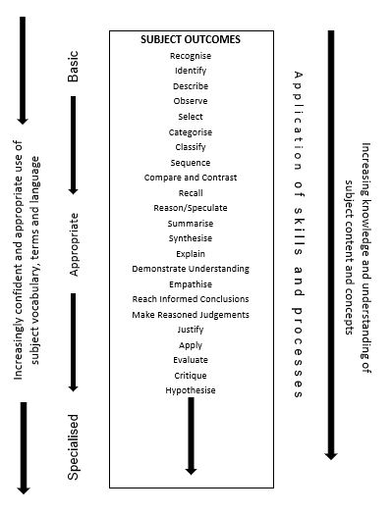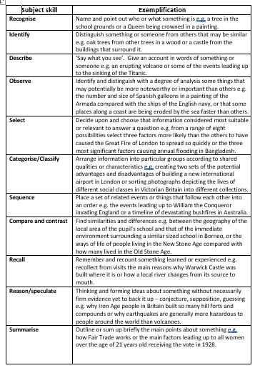
In order to assess impact - a guide
It is not anticipated that every learning outcome will be assessed in every enquiry, but it is recommended that teachers select a sample of outcomes to assess in each enquiry to build up a developing picture of how a pupil is progressing as a young historian. The focus should be on whether the pupil has shown that they have been able to, for example: identify; describe; compare and contrast; explain; make a judgment or evaluate and record.
It is left to the professional judgment of the teacher as to which outcomes are most appropriate and relevant to assess given the stage of learning of the pupil in question. Assessment should be accumulative over time, enabling the teacher to construct a ‘best fit’ picture of each pupil against a set of performance descriptors appropriate for the end of Key Stage 1, Key Stage 2 (Years 3 and 4) and Key Stage 2 (Years 5 and 6).

Teachers are responsible for the regular assessment of their pupils against key skills to judge the impact of teaching and learning in History. Teachers look at the learning journey of each unit studied, being aware of what the children need for their next learning and what they can take from prior learning. Units will therefore begin with an elicitation task for the enquiry and a final piece to assess progress at the end of the topic.

Children’s progress is monitored against National Curriculum expectations and key skills. Judgement is informed through use of children’s books, dialogue, evidence on Sway and Tapestry, and AFL pieces. Teachers need to be clear on how the children will show their learning, through a presentation, art work or extended writing, for example, providing opportunity for pupils to communicate their learning in a variety of ways.

The progress of children with SEND who find writing and communication a barrier to completing a written assessment could be assessed using a prior knowledge video or an adult scribing, this being repeated at the end of the unit where they have an opportunity to express and explain their knowledge and understanding. From this, the teacher is able to make a judgement of progress achieved from the beginning to the end of the unit.

There is an expectation that History learning in books will be the same quality as that in English books. Marking and feedback in History should be the same standard as marking/feedback within other learning across the curriculum, including English. The focus for spelling corrections is on History vocabulary and the expectation is that children who are ARE will spell these correctly throughout their History writing.

We measure the impact of History through the following methods:
- Using ICT, to gather images and videos of the children’s learning
- Marking written work
- Moderation of children’s learning in staff meetings, allowing opportunities for dialogue between staff members
- Annual reporting to parents on their child’s progress
- Learning Walks
- Moderation of children’s learning across our Academy
- Interviewing the children about their learning (Pupil Voice)
- Lesson observations
- Book scrutiny
- Tracking children’s progress using the assessment sheets on TEAMs
- Ensuring knowledge and progression of skills is being taught

