

Tedburn St Mary Primary
Design Technology Curriculum Plan
Our Curriculum statements are designed to be used as a supportive tool to plan teaching and learning across our school. The key skills are derived from the National Curriculum and the Scheme of Work we use to teach DT. These are spilt into individual year groups to support a progressive approach and mixed age classes.

Intent
Our Design and technology curriculum of work aims to inspire pupils to be innovative and creative thinkers who have an appreciation for the product design cycle through ideation, creation, and evaluation. We want pupils to develop the confidence to take risks, through drafting design concepts, modelling, and testing and to be reflective learners who evaluate their work and the work of others. Through our scheme of work, we aim to build an awareness of the impact of design and technology on our lives and encourage pupils to become resourceful, enterprising citizens who will have the skills to contribute to future design advancements. Our Design and technology scheme of work enables pupils to meet the end of key stage attainment targets in the National curriculum and the aims also align with those in the National curriculum. EYFS (Reception) units provide opportunities for pupils’ to work towards the Development matters statements and the Early Learning Goals.

Vocabulary

Children’s command of vocabulary is fundamental to learning and progress across the curriculum. Vocabulary is developed actively, building systematically on pupil’s current knowledge and deepening their understanding of etymology and morphology (word origins and structures) to increase their store of words. Simultaneously, pupils make links between known and new vocabulary, and discuss and apply shades of meaning. In this way, children expand the vocabulary choices that are available to them. It is essential to introduce technical vocabulary which define each curriculum subject. Vocabulary development is underpinned by an oracy culture and a tiered approach. High value is placed on the conscious, purposeful selection of well-chosen vocabulary and appropriate sentence structure to enrich access to learning and feed into written work across the curriculum.
For module-specific vocabulary for each year group, please see the following document: https://thelinkdevon.sharepoint.com/:b:/s/StaffListTedburn-Staff/Ec0oSmI3tBpOu4whzp4Ct8oBwXx6TVrZ4BGiqNgA1UijcQ?e=0v4bjx

Implementation
Design and technology at Tedburn follows the National curriculum, which outlines the three main stages of the design process: design, make and evaluate. We use Kapow DT curriculum to support the effective delivery of DT across school.
Each stage of the design process is underpinned by technical knowledge which encompasses the contextual, historical, and technical understanding required for each strand.

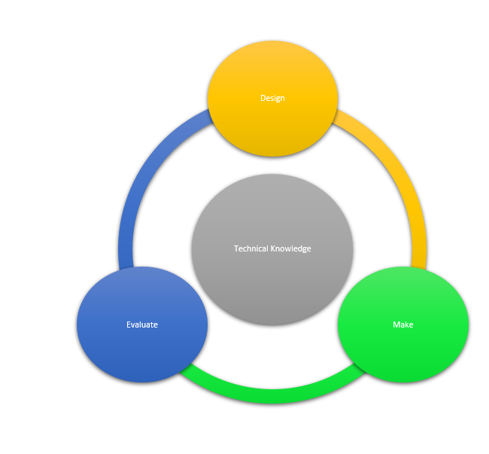
● Cooking and nutrition is given a particular focus in the National curriculum and pupils revisit this subject throughout their time at Tedburn Primary School, along with:
● Mechanisms/ Mechanical systems
● Structures
● Textiles
● Electrical systems (KS2 only)
● Digital world (KS2 only)

Through our DT scheme, pupils respond to design briefs and scenarios that require consideration of the needs of others, developing their skills in the six key areas. Each of our key areas follows the design process (design, make and evaluate) and has a particular theme and focus from the technical knowledge or cooking and nutrition section of the curriculum. Our DT curriculum is a spiral curriculum, with key areas revisited again and again with increasing complexity, allowing pupils to revisit and build on their previous learning. Lessons incorporate a range of teaching strategies from independent tasks, paired and group work including practical hands-on, computer-based and inventive tasks. This variety means that lessons are engaging and appeal to those with a variety of learning styles. Differentiated guidance is available for every lesson to ensure that lessons can be accessed by all pupils and opportunities to stretch pupils’ learning are available when required. Knowledge organisers are being trailed for each unit support pupils in building a foundation of factual knowledge by encouraging recall of key facts and vocabulary.

Art and DT rolling programme
 | Autumn 1 | Autumn 2 | Spring 1 | Spring 2 | Summer 1 | Summer 2
EYFS | Junk modelling | Drawing  Explore mark making using different media. Use the language of texture. | Soup | Painting  Child led paintings using fingers and natural items as tools. Mix colours and explore abstract/figurative. | Boats |  | Sculpture  Manipulate playdough and clay to create models. Develop language associated with forces.
Years  1 & 2  Year A | Food Technology | Drawing  Develop observational drawing skills using a range of tools. Investigate how texture can be created. | Mechanisms | Painting  Explore colour mixing using a range of tools on different surfaces. Be inspired by an artist who uses paint as their main medium. | Structures | Sculpture  Develop skills in manipulating paper and card and create 3D shapes and structures.
Years  1 & 2  Year B | Structures | Drawing  Using storybook illustrations, children develop their mark making skills and explore a wider range of tools. | Textiles | Painting  Consolidate knowledge of colour mixing and create textures in paint using different tools.  Take inspiration from a collage artist and create their own. | Mechanisms | Sculpture  Develop ability to work with clay. Explore techniques such as cutting, shaping, joining and impressing into clay.
Years  3 & 4  Year A | Electrical and Mechanical Components | Drawing  Using botanical drawings and scientific plant studies, explore techniques of artists who focus on natural forms. Children become aware of differences in the choice of drawing medium, scale and tonal shading. | Food Technology | Painting  Investigate making their own paints, making tools and painting on different surfaces. Explore prehistoric art. | Mechanisms, axels, pulleys, gears, levers | Sculpture  Explore how shapes and negative spaces can be represented by 3D forms. Manipulate a range of materials, learning ways to join and create free standing structures.
Years  3 & 4  Year B | Structures | Drawing  Using everyday electrical items as a starting point, pupils develop an awareness of composition in drawing and combine media for effect when developing a drawing into a print. | Textiles | Painting  Developing colour mixing skills, using shades and tints to show form and create three dimensions when painting. Pupils learn about composition and plan their own still life to paint, applying chosen techniques. | Digital World | Sculpture  Exploring the way different materials can be shaped and joined, learning about techniques used by artists as diverse as Barbara Hepworth and Sokari Douglas- Camp and creating their own sculptures.
Years  5 & 6  Year A | Electrical and Mechanical Components | Drawing  On a journey from the ancient Maya to modern-day street art, children explore how artists convey a message. They begin to understand how artists use imagery and symbols as well as drawing techniques like expressive mark making, tone and the dramatic light and dark effect called ‘chiaroscuro’. | Painting  Investigating self- portraits by a range of artists, children use photographs of themselves as a starting point for developing their own unique self- portraits in mixed media. | Food Technology | Sculpture  Using inspiration of historical monuments and modern installations, children plan by researching and drawing, a sculpture to fit a design brief, They investigate scale, the display environment and possibilities for viewer interaction with their pace. | Mechanisms, axels, pulleys, gears, levers
Years  5 & 6  Year B | Structures | Drawing  Develop ideas more independently, pupils consider the purpose of drawings as they investigate how imagery was used in the ‘Space Race’ that began in the 1950s. They combine collage and print making to create a piece in their own style. | Textiles | Painting  Identifying an artist that interests them, children research the life, techniques and artistic intentions of that individual. Collecting ideas in sketchbooks, planning for a final piece and working collaboratively, they present what they have learnt about the artist. | Digital World | Sculpture  Creating a personal memory box using a collection of found objects and hand- sculptured forms, reflecting primary school life with symbolic and personal meaning.

CPD
Strong subject knowledge is vital for staff to be able to deliver a highly effective and robust Design and technology curriculum. Each unit of lessons in the scheme we use, includes multiple teacher videos to develop subject knowledge and support ongoing CPD as some teachers may not feel confident delivering the full Design and technology curriculum. This ensures that the implementation of our curriculum delivers lessons of a high standard that ensure pupil progression.

The National Curriculum
Key stage 1
Through a variety of creative and practical activities, pupils should be taught the knowledge, understanding and skills needed to engage in an iterative process of designing and making. They should work in a range of relevant contexts [for example, the home and school, gardens and playgrounds, the local community, industry and the wider environment].
When designing and making, pupils should be taught to:
Design
- design purposeful, functional, appealing products for themselves and other users based on design criteria
- generate, develop, model and communicate their ideas through talking, drawing, templates, mock-ups and, where appropriate, information and communication technology
Make
- select from and use a range of tools and equipment to perform practical tasks [for example, cutting, shaping, joining and finishing]
- select from and use a wide range of materials and components, including construction materials, textiles and ingredients, according to their characteristics
Evaluate
- explore and evaluate a range of existing products
- evaluate their ideas and products against design criteria
Technical knowledge
- build structures, exploring how they can be made stronger, stiffer and more stable
- explore and use mechanisms [for example, levers, sliders, wheels and axles] in their products
Cooking and nutrition
Key stage 1
- use the basic principles of a healthy and varied diet to prepare dishes
- understand where food comes from

Key stage 2
Through a variety of creative and practical activities, pupils should be taught the knowledge, understanding and skills needed to engage in an iterative process of designing and making. They should work in a range of relevant contexts [for example, the home, school, leisure, culture, enterprise, industry and the wider environment].
When designing and making, pupils should be taught to:
Design
- use research and develop design criteria to inform the design of innovative, functional, appealing products that are fit for purpose, aimed at particular individuals or groups
- generate, develop, model and communicate their ideas through discussion, annotated sketches, cross-sectional and exploded diagrams, prototypes, pattern pieces and computer-aided design
Make
- select from and use a wider range of tools and equipment to perform practical tasks [for example, cutting, shaping, joining and finishing], accurately
- select from and use a wider range of materials and components, including construction materials, textiles and ingredients, according to their functional properties and aesthetic qualities
Evaluate
- investigate and analyse a range of existing products
- evaluate their ideas and products against their own design criteria and consider the views of others to improve their work
- understand how key events and individuals in design and technology have helped shape the world
Technical knowledge
- apply their understanding of how to strengthen, stiffen and reinforce more complex structures
- understand and use mechanical systems in their products [for example, gears, pulleys, cams, levers and linkages]
- understand and use electrical systems in their products [for example, series circuits incorporating switches, bulbs, buzzers and motors]
- apply their understanding of computing to program, monitor and control their products
Cooking and nutrition
Key stage 2
- understand and apply the principles of a healthy and varied diet
- prepare and cook a variety of predominantly savoury dishes using a range of cooking techniques
- understand seasonality, and know where and how a variety of ingredients are grown, reared, caught and processed

Progression of Key Skills
Please see our Kapow DT progression of skills document: Mixed-age-DT-Progression-of-skills-and-knowledge-01_09_22.pdf

In order to assess impact - a guide
The impact of our Design and Technology Curriculum can be constantly monitored through both formative and summative assessment opportunities. Each lesson within the Kapow scheme that we follow includes guidance to support teachers in assessing pupils against the learning objectives.

With our Design and technology, pupils should leave school equipped with a range of skills to enable them to succeed in their secondary education and be innovative and resourceful members of society. The expected impact of following the scheme we follow is that children will:

➔ Understand the functional and aesthetic properties of a range of materials and resources.
➔ Understand how to use and combine tools to carry out different processes for shaping, decorating, and manufacturing products.
➔ Build and apply a repertoire of skills, knowledge and understanding to produce high quality, innovative outcomes, including models, prototypes, CAD, and products to fulfil the needs of users, clients, and scenarios.
➔ Understand and apply the principles of healthy eating, diets, and recipes, including key processes, food groups and cooking equipment.
➔ Have an appreciation for key individuals, inventions, and events in history and of today that impact our world.
➔ Recognise where our decisions can impact the wider world in terms of community, social and environmental issues.
➔ Self-evaluate and reflect on learning at different stages and identify areas to improve.
➔ Meet the end of key stage expectations outlined in the National curriculum for Design and technology.
➔ Meet the end of key stage expectations outlined in the National curriculum for Computing.

