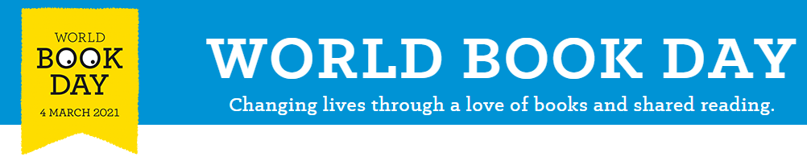Potato book characters
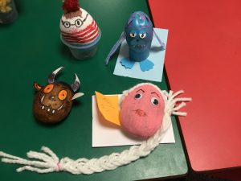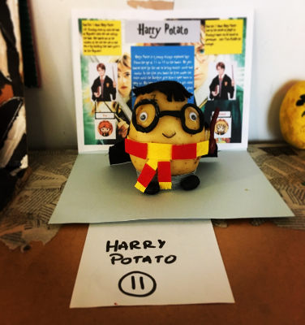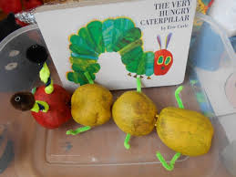
Potato Book Character Competition
Instead of dressing up for World Book Day, why not decorate your own potato as your favourite book character. Use paints, pipe cleaners, wool, pens, material and anything else you have around your house. Be as creative as possible!
To enter simply take a photo of your Potato Character and write a short paragraph explaining why they are your favourite book character and upload to Teams. There will be a winner selected from each class. Winners will be announced on Friday 5th March. Good Luck!

