Online Learning Chinese New Year Friday 12th February
Choose 3 to 4 of these activities to complete throughout the day. Upload a piece of work that you are proud of to Teams or Tapestry.
Whole School Assembly  Join us at 9.10 to find out about the story of the Chinese New year.  Join us again at 3.00 to celebrate work that you are proud of that you can share with everyone. | English  Willow/Birch  Share the E-Book story ‘Dragons in the City’  In what animal year were you born? Use the online calculator by following the link below. https://www.travelchinaguide.com/intro/social_customs/zodiac/  Can you find out some information about this animal and what influences the Chinese believe will have on a person born in the year of this animal.  Ash/Oak  Chinese New Year Reading Activity  Chinese traditions wordsearch | Maths/MFL  Willow/Birch  Learn to count to 10 in Mandarin  https://www.bbc.co.uk/programmes/p00q91g7  Ordering and sequencing game  https://www.topmarks.co.uk/ordering-and-sequencing/chinese-dragon-ordering  Ash/Oak  Learn to count to 20 in Mandarin  https://www.youtube.com/watch?v=1pd64abZZM8  Maths code breaker activities  Tangrams  Learn about the ancient Chinese puzzle, Tangram.  https://nrich.maths.org/6715  Online activity  https://nrich.maths.org/1 | Geography  Question to explore:  Where in the world is China? Can you locate it on a map? Which continent is it in?  What animals are native to China?  What famous Chinese landmarks can you find out about?  What is the Great Wall of China?  Colour in or create your own Chinese flag.  Great Wall of China Construction Challenge | History  All about Chinese New Year  Power point  Can you find 5 facts to share about Chinese New Year.
PE  Dragon and Lion Dance  Watch the Powerpoint videos Dragon and Lion dances.  What do you like about the videos?  Dress up in bright colours and perform your own dragon or lion dance. | DT  1.Make a paper lantern  2.Chinese 3D dragon fortune teller  3.Create a dragon mask  4.Dragon Cookies | Music  Make a Chinese Paper Drum  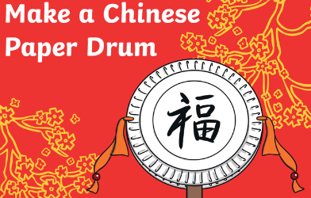 | Art  1.Chinese dragon colouring sheet.  2. Chinese new year peg dragons | Art  Use the ‘How to draw a Chinese dragon’ video to draw your own Chinese dragon.  Easy  Chinese dragon colouring sheet (see resources)  Medium  https://www.youtube.com/watch?v=8h3xm1RDZaQ  Hard  https://www.youtube.com/watch?v=KbllBUxaNMU

